Chapter 30 - Beyond

Beyond

30.1 - Introduction
Over 30 chapters, we have discussed and implemented quite a few machine learning algorithms. The first part of this course dealt with conventional methods, and we worked through algorithms designed specifically for classification, regression, clustering, and natural language processing. It hopefully gave you, the reader, an understanding or at least an intuition on how these algorithms work, how they can be trained succesfully using methods like gradient descent and expectation-maximization, as well as what metrics of performance and success we should consider in evaluation the algorithm. In the half, we discussed neural networks, from their humble beginings simulating logic gates to the massive deep belief neural networks of today that can classify, cluster, transform and even generate complex data sources, such as images. To many, the neural networks have begun to replace the use of conventional methods. Neural networks are more flexible, and the same frameworks can be repurposed to build many different type of DBNN architectures. Changing the algorithmic objective (e.g. from regression to classification) requires only a modest change to the objective the neural network is minimizing (i.e. loss), rather than having to implement a new algorithm from scratch. There are however a few approaches to AI and machine learning that are quite specialized, niche and unique. We will discuss a few examples in this chapter.

30.2 - Reinforcement Learning
One novel approach to AI, referred to as reinforcement learning, has gained a lot of interest recently. Traditionally, machine learning algorithms were trained completely supervised or unsupervised. Either we know exactly what the desired output should be (supervised learning). Or we have no ground truth of the desired output should even be, relying instead on statistical regularities (unsupervised learning). Reinforcement learning takes a more ecological apporach, mimicking how organisms (humans included) learn from their actions. In many cases, we are not given feedback about the exact discrepancy between our action and what the desired and most optimal action would have been. Instead, the only feedback we receive is whether our action was beneficial or decremental to the task at hand. Reinforcement learning is more difficult and slower because of this, but it also allows us to train algorithms to learn to perform tasks efficiently and sometimes in very novel ways, not imagined or considred by their human counterparts. The strategy learned is implicit. If we train a neural network to play a game, like chess, the strategy it will learn isn not explicitely based on theory on how to engage your opponent in certain known patterns. Rather, the algorithm has learned to associate each configuration of the board and any subsequent possible move from this configuration with an eventual win, or loss. This approach was used for AlphaGo Zero, the highly succesful Go playing algorithm that defeated top Go player Lee Sobel in 2016.

Key to designing algorithms that use reinforcement learning is to recognize the differetn parts of the systema s whole and how they interact. Generally, 5 key parts are identified.

Renfrocement learning takes place in a physical or digtial world. A physical enviroment could be the space a robot needs to learn how to nagivate. A digital world can be a game world, as simple or complex as they come.
Our algorithm is referred to as an agent, and as an agent it receives information about the eivnrioment and can choose to take an action that influences both the agent and the world. from the perspective of the agent. For example, moving our robot 1 foot to the left constitutes an action taken. As a result, thew orld from the perspective of the agent has also hcanged: its onboard camera now registers a slight different scene in front of it. What the agent does next depends on its state and goasl. In a game the goal is straightfoward: win. Other enviroments might require more complex goals suchas making sure the robot returns with at least half the items it was send out to collect from the warehouse). Its current state is all the relevant information the agent needs to achieve its goals, both internal and external. Relevant external information are the inputs it receives through its sensors, reelvant inernal information could be the amount of battery life left to our robot agent. A policy refers to how these states and hgoals map onto a set of possible actions and finally value refers to the reward an agent would receive by taking a particular action in a paritcular state.

A number of ways to implement reinforcement learning have emerged, adapting older techniques to work with deep belief neural network models. This includes such algorithm like the DQN (Deep Q Network) algorithm, its variant Dueling DQN, Monte Carlo Policy Gradients, Rainbow, Proximal Policy Gradients (PPO) and advtange actor critic (A2C).
Reinforcement learning, especially when utulizaing deep belief neural networks to represent and search for optimal solutions is a new, but already highly sophicated subfield of machine learning. As such, we decided against dedicating a chapter to it, for fear of falling between explaining it in sufficient detail on the one hand, and having at least touched upon the method and its use cases on the other. Instead, we included it here, but made sure to also include code code in the form of demo notebooks to get anyone with an interest started (see below). We further encourage the interested reader to explore the topic starting with the references included in this chapter.

30.3 - Playing Games - Space Invaders

Research platform OpenAI has developed a very useful tool for exploring using reinforcement learning in teaching algorithms how to play video games. The openAI gym. provides an interface to a large numbe rof classic arcade games, (e.g. break out, space invaders and qbert) that can beused programmatically to train and test AI playing these games. The gym simulates the game world, taking in inputs from an algorithm that mimic a human player's options (move left, fire, jump) and the gym will play out this action in the game, returning to our algorithm future game states which incoorpeates the algorithms action and its effects on the game world. In the accompanying notebook to this paragraph we will work through training an algorithm to play Space Invaders, using ereinforcement learning.

30.5 - Genetic and Evolutionary Algorithms
Some computational tasks are expectionally hard for computers to solve within a resonable amount of time, and a responable amount of resources (.e.g memory). A special class of these tasks is even said to be NP hard. n computational complexity theory, NP-hardness (non-deterministic polynomial-time hardness) is the defining property of a class of problems that are informally "at least as hard as the hardest problems in NP". This is a rather vague definition, so let us also share a more intuitive one. A problem is considered NP-hard when we believe there exists no algorithm that scales in memory resources and time needed to test all possible solutions to a certain input.T ypically, NP hard problems suffer from a combinatioral explosion of solutions. Think of even a modestly sized graph of n nodes, the number of edges is n * (n-1) if nodes cannot be connected to themselves and the graph is directed. So, for a graph of 3 nodes, there are 6 edges, and for a graph of 10 nodes there are 9900 edges. Now imagine of the number of possible paths that visit every node n once and only once. For a graph of 3 nodes, we have have 6 paths possible paths, but already at 10 nodes, we have 3.6 million+ paths, as the number of possible path p for n nodes is given by n! (n factorial, computed as n * (n-1) * (n-2) * . The above highlights the difficulty of the classic traveling salesman problem (TSP) in computer sicence: If our salesman needs to visit n number of cities at least once, how do we effciently finds the shortest path between cities that accomplishes that? To find the apth, we will have to iterate through every possible path and compare it to some current global shortest path in memory. The amount of time such a brute force algorithm will take is given by the number of paths, and for this particular problem, there isn't a smarter more efficient algorithm that can do it faster, as far as we know.

Instread, problem like the Traveling Salesman can be solved, at least by approximation, by evolutionaty or genetic algorithms. Both genetic or evolutionary algorithms rely the mechanisms of evolution found in nature to the problem of finding an optimal solution: fitness, selection, mutation and crossover, which we discuss in greater detail below. After discussing these mechanisms we will have the nesessary vocabulary to explain the precise difference between evoluitonaty and genetic algorithms. In both types of algorithms, we explore many possible solutions to our computational problem at once. First, we generate a large number 'individuals' that each encode a potential solutions to our problem. For example, in the traveling salesman problem, we initialize our population of individuals by given each one a random ordering of the n cities to be visited. You can think of this sequence of n unique nodes as the individual's DNA, the genetic code we are trying to optimize.

If the number of individuals we initiaize is small in comparison to the number of possible paths, it is likely none of these individuals is already the most optimal solution (i.e. the shortest path). Instead, some individuals might have partially optimal solutions, meaning they got some transitions of the most optimal path right by chance. But the majority will encode a path that is far from optimal. The optimality of an individual's solution (i.e. path) is used to rank the individuals based on their fitness. The shorter the total length of the path encoded, the higher the fitness. The use of a population of solutions helps the evolutionary algorithm avoid becoming "trapped" at a local optimum, when an even better optimum may be found outside the vicinity of the current solution. The population explores the state space of solutions in many different directions, in contrast to for example gradient descent where a single solution is optimized continiously by adjusting the parameters of the model. The exploration is iterative, and consists of 3 steps: selection, cross-over and mutation.

Selection. After the initial population has been created and each individual assigned a fitness value, we select 50% of the inviduals in population assocaited with the hifghest fitness vaes and divide them into two groups of equal size. The remaining 50% of individuals with the lowest fitness scores are removed from the population.

Cross-over. Borrowing from bological reproduction, every individual from one group is combined with one member of the other group. These 'parent' individual then create 2 offspring individuals using a technique called cross-over. There are more than one way to do cross-over, but all work by selectively recombining the 'genetic material' from both parents. Each parent may have had a subpath (.e.g 2 -> 3 -> 4 of the most optimal path (1 -> 2 -> 3 _> 4 -> 5) aleady encoded, and the goal is to end up with offspring inheriting and recombining these optimal subpath. Of course, it is equally likely the offspring inherits the worst subpaths from its parents, resulting in a lower fitness score for the offspring , relative to the parents. As such,it is unlikely not be included in the next set of parents selected to produce new offspring, so their lineage encoding a poor solution will not continue.

Mutation. In addition to crossover, another biological process is also used to generate variability: mutation. Mutation in our traveling salesman problem can be accomplished by randomly swapping one or more of the nodes in an individual's encoded path, with some low probability.

Since we used 50% of the initial population to generate offspring by taking two individuals and having them produce exactly 2 offspring means that the population size stays the samne. The individuals that had a fitness lower than the population median were removed, and replaced by an euqal numbe rof new indivudals, the offsrping of the idnviduals who had a fitness higher than the population median. Selection, cross over and mutation comprise a single step in the evolution of the population, and is repeated until the fitness of the population appears to stabilize. At this point, we can take the most fit indivudal(s) as the solution of our problem. However, it is important to rembember that the most optimal solution onlyimial opt relative to all other solutions the population explored. It is not garantueed to be the optimal solution across all possible paths, especially when the number of possible paths is high. If we wanted to know whether it was the most optimal solutin theorectically, we find oursleves having to apply the brute force approach to first find the most optimal solution to comparie to what our evoltionary process has produced over many generations, defeating the purpose of the evolutionary approach all toggether). However, many differennt genetic and evolutioanry algorithms have found solutions for problems that are optimal or very close to optimal. In addition, and perhaps more exciting, genetic/evolutionary algorithms have found solutions to problems more optimal than the ones created by humans, solutions that often appear counterintuitive to those same human experts, but work none theless.

Returning to the definition of and disctintion between the terms genetic and evolutionary algorithms, we note that they are often used interexchangible, but that they are not the same. All algorithms that adapt and evolve in way that is analagous to natural selection and evolition in biolohgical system can be called evolutioanry algortihms. Genetic algorithms can be seen as a subclass of these algorithms. Tthese algorithms represent their solution as a genetic code similar to DNA, typically as bit strings that the indvidual uses as instructions to determine its fitness. Encoded in this way changes how new individuals are produced by combining parent indivduals during cross over and snd mutation. For example, imagine a evolutionary algoithm finding the best solution to the following set of equations

y = ax + bx2 + cx3 + d

In other words, we need to the best values of a, b, c and d as to produce an outcome as close as possible to some ground truth. When two individuals are paired to produce new offspring, one way they can recombine is to represent each individual of having 4 unique values. When two individual have a high fitness we can recombine these individuals by perhaps producing offspring with parameters a, b, c and d that are some weighted average of these values in their parents. The idea behind this is that two individuals have a high fitness because their own parameters a,b,c and d are relatively close to the optimal solution, than a weighted average between individuals has a reasonable chance of producing an even higher fitness. In a genetic algorithm, we instead encode these four parameters as bit strings. During cross-over, individual bits are swapped, without regards to the thing they help encode (the paramters). This is a more sublte way of recombining what we deem as 'fit' solutions into even fitter ones, and one that works well for certain problems, and less well for others. We will provide an example of each in the following two sections and accompayning demo notebooks.

30.4 - Travelling Salesman

30.5 - Efficient Nanobots

30.6 - Genetic Algorithms for Protein Folding
The games offer an inituitive way to explain the concepts behind evoliotnary and genetic algorithm, but the application of these algortihms to other domains has generated far greater interest. One such domain is the problem of protein folding. Proteins are large moleclus that serve many different roles and functions in biology. As molecules, proteins are long strands of connected atoms that are folded in intrecat ways. Not only does that make them fit inside the small confines of a cell, it also dictates their properties and interactions with the biological system they are part off. Understanding how a protein is folded and how this changes its function would greatly advance and speed up medical science. The goal is to reverse engineer the proteins, starting from their benefincial medicinal properties and ability to cure a diesease to the folding of the protein this function requires. This is in contrast with the current situation where a lack of understanding protein folding and function forces pharmacitucal research to take on a trial and error approach, cylcing through many differnt folding permutations before hopefully landing on one that has the desired properties. Evolutionary and genetic algorithms have been succesfully used in revamping this cumbersome expensive and time consuming process, and provide a way forward to engineer ever more complex proteins to cure our collective ailments and diseases.

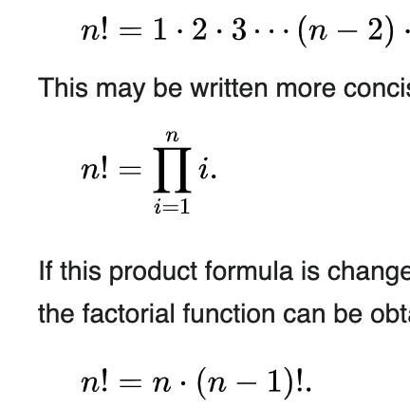

30.4 - Agent-Based Modeling
As our infrastructure, process, operations and architectual designs continue to grow in complexity, we need new ways of understanding how interconnected systems at different levels of organization work together, and when the fail to work together. Designing a new airplane is done with the help of computer-aided design tools, and the resulting computer models can be used in a variety of simulations for testing. This digital twin of the aircraft we are designing can be used in simulations, subjecting our design to physical constraints and forces, for example in a simulated (i.e. digital) wind tunnel, or the effect of outside forces, like the wear and tear of moving parts over time due to heating, friction and strain. Although this can of design process is now very common, a more recent development is now considering not just the solution we are designing, with its physical and/or moving parts, the physical constraints imposed on it, and the specifications needed to be met to create a safe, efficient and cost-effective new technology. Instead, it focuses on the complex interaction between the solution between designed and the key players that will interact with it.

The approach is called Agent Based Modeling (or ABM). Historically, ABM

ABM is a helpful tool when studying complex systems and/or enviroments. Systems and enviroments are made of many parts, all of them imposing some constrains and affordances to the larger system. We can think of these systems as physical, like the planets revolving around our sun in our solar system, or Or the system can be more abstract, like a game, a herd, flock or pack of animals, or an economy, or an ecosystem, even societies, belief systems and religions can be modeled as systems with parts. An environment can be an abstraction of a real physical envrionment, like an operating room. We can model the things we consider important, like any ingress and egress to the OR, or the position of the various parts of equipment. At the same time, we can leave out other things, such as the paint color of the wall.
Some of the parts are more interesting then others, and we refer to them as agents. Agents too can take on many forms, but what sets them aparts from the apart from the other parts in the system is that agents have agency. The agents have goals, internal states, can receive (limited) information about their enviroment and influence it by means of action. In other words, the agents aren't passive in their envrionent, changing behavuor only when perturbed. Instead, they work actively within their environment to reach their goals. However, that doesn't mean these agents need to be intelligent, consicuous, moral, ethical lifeforms capable of complex goal directed problem solving. Anything can be a goal. Consider a thermostat. It has a clear goal: maintain a particular temperate set by the user. It can sense its enviroment by measuring its temperature, and it can influence its environment by turning on the heat, or cooling system. Finally, it has internal states, such as 'heating' or 'cooling on' or 'idle'.

AMB focuses on understanding the interplay between environment and the agents in it. Even for moderately complex systems, it becomes impossible to describe all states and transitions between them fully from first principles. In complex systems, the behavior of its part and the evolution of this behavior depends crucially on the initial state the system was in. As they evolve over time, the behavior of such system can be erractic and even chaotic, before returning to a more stable state or predictable transitions between states. Imagine three spherical objects (e.g. planets or billard balls), each with its own mass and initial velocity and position find themselves close enough together to exert an infleunce over eachother, by means of a gravational pull. Each of three objects is attrating the two other ones, moving towards eachother and being catapulted away like a sling shot when they get too close (this is how some planetary mission get space crafts where they need to be in reasonable time: the sun and larger planet's gravitational pull can slingshot a made man probe towards its destination at great speed). As a result, the three objects move in a continious but unpredictable dance around eachother. Outside of physics, ABM is used to hel punderstand regularities and structure of complex systems that give rise to emergent properties not directly deducible from examining each part in detail. Think of the flocking of swarms of birds, the coordinated behavior of ants, bees and termites that result highly effective and stable societis. and the construction of efficient physical structures like bee hives and termine mounds. Each individual ant or bee is likely to be completely unaware of the bigger plan, having no insights into its individual contributions to the ergement whole. Insterad, each operates with a small number of very simple rules to follow. It is when collection of such agents each selffelishly tries to follow those rules, we might see unexpected collective and complex behavior arise.

The agents have rules, but they are also constrained by their enviromnment. This is where ABM has the potential to become an essentia tool for designing and embedding new technologies, including AI, into our environments. We can ask ourselves what aspects of the enviroment we place our agents in is both necessary and sufficient for the emergent behaviors of the agents to be observed. And with that, we can improve the design of such enviroments digitally, before it is 1) actually build 2) the agents interacting with it find it is deeply flawed in how it constrains the agents.

30.4 - Agent-Based Modeling - ABM aided Design
Tthere are many complex systems of interest at MSK, some of which are likely to be improved on with insights gleamed from ABM. For example, we can model the dynamics of a hierarchical organization, with reporters and reportee, in order to understand whether the specifics of such a system can cause bottlenecks for the flow of interformation. Similarly, we can model the logistics and supply chains necessary in running a large treatment center, on the look out for disruptions that occur at various tipping points: a point in time during which a complex system changes from one regime of behaviors to another very different regime. Tipping points are very heard to anticipate. In complex system, we simply can't fully predict every single state a system can be in, as only the slightiest difference in intitial conditions make the outcome unpredictable. Modeling and simulating the system instead, over many different initial conditions, might reveal and help us gain insight in the sudden changes in system behavior that might occur. Before making this more concrete and reelevant to the work here at MSK, we will briefly discuss a few simpler models that are often used to introduce ABM as a method.

30.4 - Agent-Based Modeling - Game of Life

30.4 - Agent-Based Modeling - Flocking

30.5 - 30.4 - Agent-Based Modeling - Segregation

30.5 - Agent-Based Modeling - Evacuation Model
The last model we will discuss is the most relevant to how we envision ABM to be used to guide and aid in the design of our physical infrastructure and embedding of new technologies within it. In a famous paper, XXXX created a simulation in which humans had to evacuate a space, in response to some adverse event, for example a fire breaking out. Think of the complexity of each agent in that simulation. Each of them a human individual, a highly complex biological entity, with his or her personal goals, drives, motivations, agendas, perspectives. Each of them a human individual of physical dimensions, detailed but also limited sensory inputs, and a range of possible interactions with its enviroment at its disposal (screaming, whsipering, waving, sitting down, jumping, singing). What was groundbreaking in the appraoch taken by XXX was to deem almost all of that irrelavent. Instead, he choose to model human individuals as digital grains of sand. And the only rule these sand agents were given was to move out of the space. If the space is mostly empty, each individual will be hardly impeded by any other individual. However, make the space too crowded (the tipping point), and all of a sudden the agents will end up in each others way. And as with sand, the agents now behave as particles, causing friction between those touching and slowing down their progress towards especaing the space. When we model this pbehavior, we can change the environment in which this happens. We assume the agents will always follwo the same rule, so in order to have as many poeple espace in as little time as possible, we can look to the enviromnent to facilitate this. Interestingly enough, this apporach yielded some intereting and unexpected design pricniples, very likely not the ones an human architect would consider. For example, as you can see in figure 23223, placing a large round column in front of the exit actually improves the number of agent escaping the space within some unit of time. Turns out a round column in the way actually does 2 beneificial things. First its roundness decreases friction between it and the agents, preventing many agents from getting stuck. Second, it effectively splits the agents in two subsets (one going around the column in way direction, the other one in the other direction). This decreases the number of agents close together, and as such decreases the friction between agents, and allows agents to move faster towards the exit.

30.4 - Agent-Based Modeling - Designing an ICU
Using the above logic, we propose we can use ABM to test the interplay between the environment (the physical layout of the ward, with its affordances and constraints) and the agents in it (clinicians, like nurses and doctors, patients, family, members, supporting staff, etc). For example, how do we design an ICU that scales gracefully as the number of people in it is increased? Can we observe and understand possible tipping points using an agent based model in order to redesign, rethink and prevent it from happening? Imagine the clinicians (mostly nurses) on the ICU, attending to the patients, which includes taking their vitals, administring medications, drawing blood, answering patient questions, and escalating the care if needed (if a patients suffers a cardiac arrest, for example). In most hospitals, the nurse's station functions as. a base of operations. From it, clinicians are dispatched by their schedule or patient demands to attend to them. This creates substantial foot traffic in expensive real estate that isn't designed with space in mind or as a priority. With a reasonable amount of patients, this system can operate without too many delays. However, just as in the fore fire example above, at a certain point there are too many patients needing to many interaction touchpoints, and with one additional patient, a system in flow might become a system in grid lock. ABM might be able to predict those tipping points, or other adverse and unforessen emergenet ill effects the design of an enviromnet can have. It informs and forces designers, engineers and other stakeholders to reimagine the enviroment to mitigate these ill effects.

30.5 - Combining Aprroaches
ABM allows us to observe and hopefully understand the ergement properties (good or bad) we might encounter in a complex system of agents and enviromnement. In conventional ABM, the agents typically only follow a small number of local rules. For example, in the flocking model, one rule was simply to in the same direction as the agents closest to you. It is a local rule, because it only specifies what action the agent can take to optimize its goal. It doesn't factor in the fate of the other agents. The agent is behaving selfishly in its own interest, not the greater good. Yet collectively, such local rules can have very complex consequences to the system as a whole. But if we want to tackle more interesting scenarios, we might have to make our agents a bit smarter, and a bit more adaptive. At the same time, obseving a tipping point in the interaction and enviroment is not enough. We need to be able to iterate on the design so whee understand what aspect of the enviroment is resonpoisble for this tipping point, we can work towards redesigning the enviroment within the constraints of the entire pghysical space in order to prevent the tipping point from happening.
The ordering of this and the previous two sections on genetic algorithms and reinforcement learning is not random. We think that a combination of thre three methodologies can help us (re)imagine and design spaces less or even not subject to emergenet but disruptive and thus decremental sceneratio. First,rather than keeping the various agents in the model simple and static, following only a few rules, we can use reinforcement learning to create adaptive AI agents, mimicking the adaptive process of humans interacting with their environment. Second, the environment as well can be implement some intelligent optimization process. For this, genetic algorithms can be used to create, mutate and combine environments if they are asscociated with a higher fitness. Over time, both the enviroment and agents will evolve, hopefully towards a stable and optimal solution, and if so, likely to a solution human designers woul dhave probably never even contilplated or cosnidered.

30.6 - Quantum Computing

30.7 - Conclusions

30.8 - Notebooks

30.9 - References

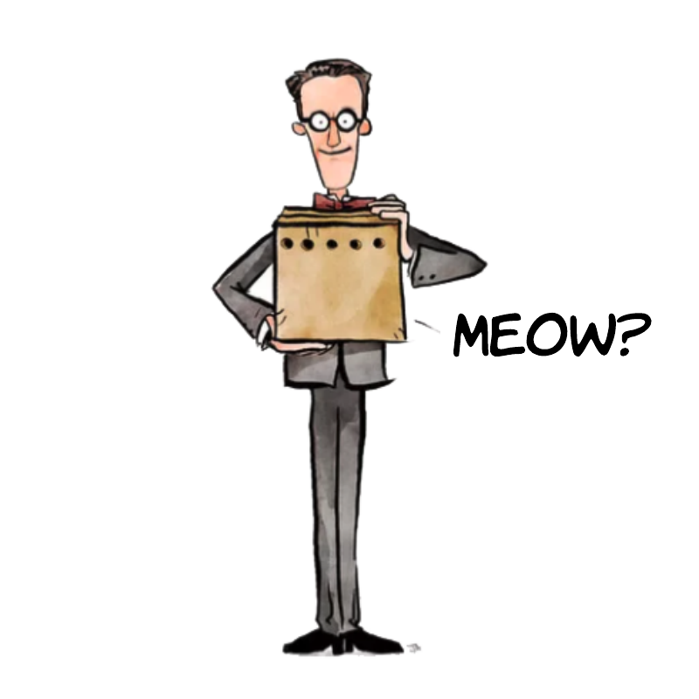
Quantum computing is the use of quantum phenomena of superposition and entanglement to perform computations.Exploiting these phenomena gives quantum computers the ability to represent, iterate over as well as search through extremely large state spaces with relatively little computing resources, such as physical memory and circuitry. As such, the applications of quantum computing focus on improving algorithms that show exponential growth in complexity in classic computing environments. Key to the understanding of the quantum world, and therefore quantum computing, is that at a subatomic level, the state (described by its attributes spin, velocity, position, phase) of particle is probabilistic until it interacts with an observer by way of measurement. This is not an easy reality to accept, but careful and repeated measurements of subatomic particles continue to be in line with this uncertaintity principle. You probably will have heard about Schrodinger's cat. It is classic thought experiment, in which Edwin Schrodinger imagined a cat in closed box, alive and well when we put it in there (although perhaps a bit miffed from having been manhandled into a box). We now fire a single photon at a half-reflecting mirror. This mirror will either reflect the photon into a different direction, or let the photon pass unimpeded in its original direction, with both events being equally likely and completely up to chance. The diverted photon will hit a detector (A) which will trigger the release of a poison in the box, killing the cat. The unimpeded photon will activate another detector (B).
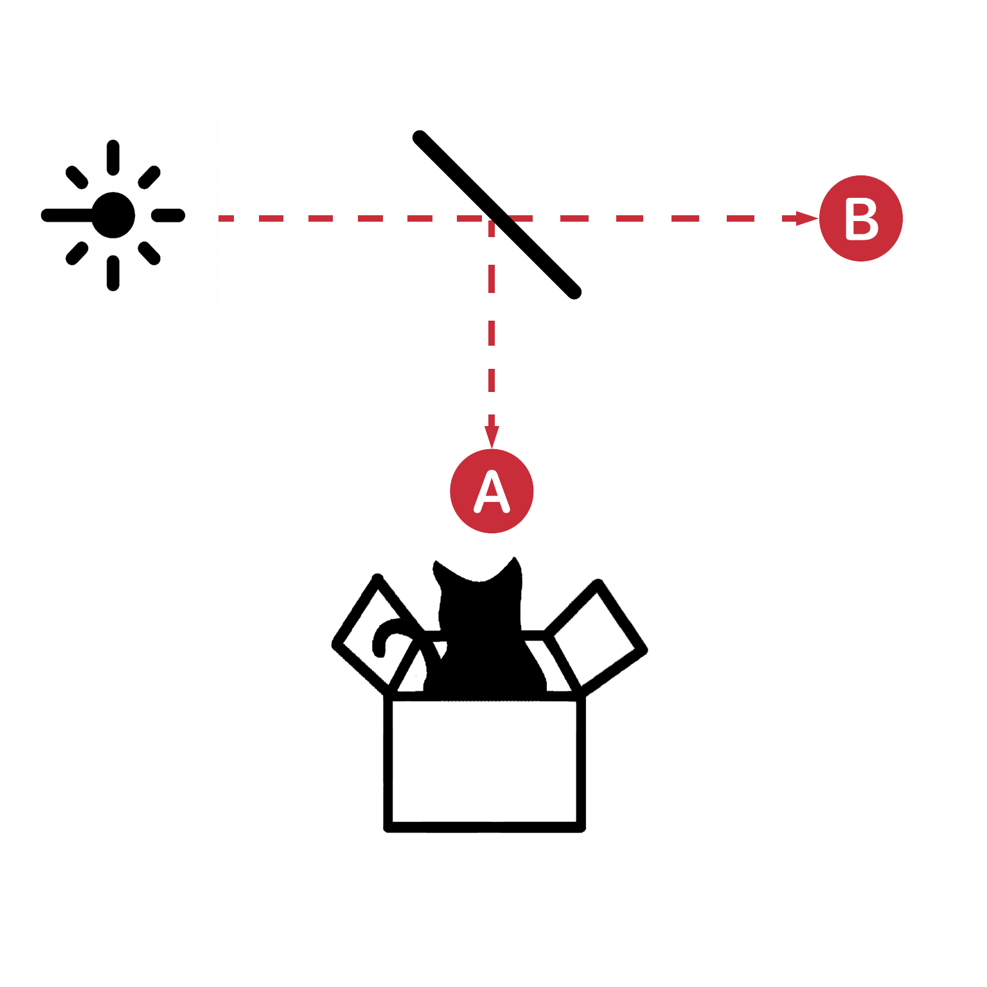
We cannot see whether either switch has been triggered without a measurement of one of the two detectors. So, what is the true state of the cat AFTER we have fired the photon but BEFORE we open the box? Is the cat dead or alive? Surely, the cat is one or the other. Truth is, we really don’t know for sure, when it comes to things the size of cats that are comprised of trillions and trillions of atoms.
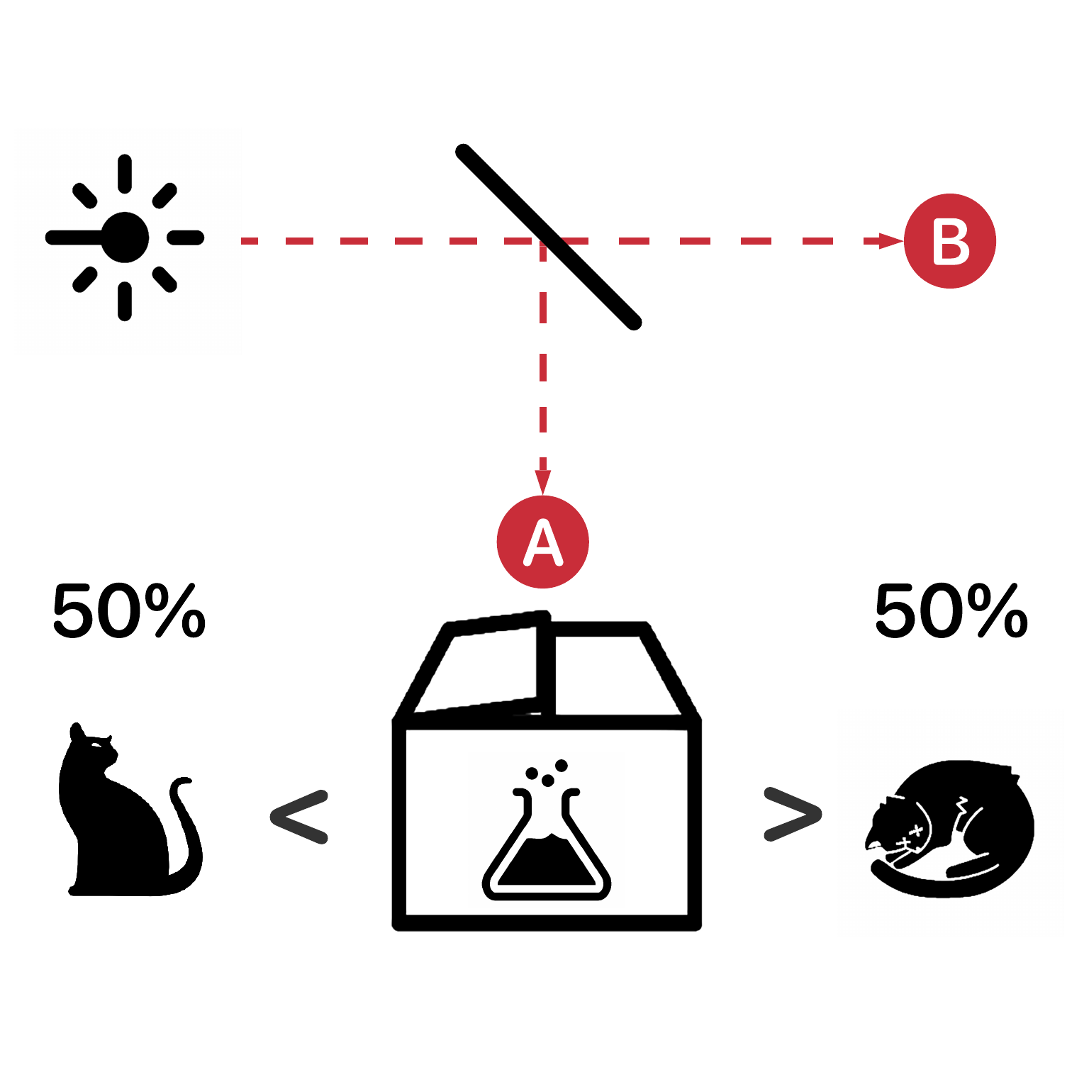
However, experimental observations at the subatomic level (photons, electrons) have shown that up until we do a measurement of the outcome by looking at either detector, the photon is said to have been in superposition. It existed with equal probabilities in both realities. When we do look at the detectors, this superposition is said to collapse into a single outcome. The probability of observing any outcome depends on the precise superposition state of the photon. In our example, the 50% reflecting mirror we give us a 50%

change of measuring the photon at A and B, but these probabilities can be manipulated by experimental manipulation.
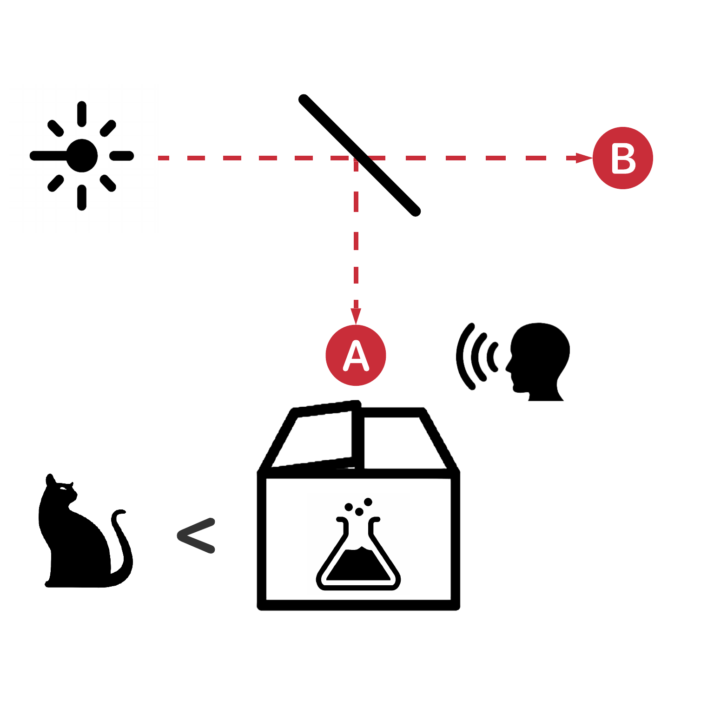
So, how does simply observing something and measuring it change its physical reality? At the subatomic level, there is no truly passive and objective way of measuring anything. To get a read on the state of particle, you need to see how it interacts with another particle. This interaction inherently changes the particle under investigation.How do these strange physical realities translate into a new way of computing? It turns out that these states of sub-atomic particles can be induced using specialized hardware. Our ability to create sub-atomic particles and put them in certain states, allow use to construct a new atomic element of data: the qubit. The qubit is to quantum computing what a bit is to classical computing. However, since the qubit comes with several interesting properties that cleverly designed algorithms can harness to yield extremely powerful tools. All of this because a qubit has an actual physical reality: a sub-atomic particle

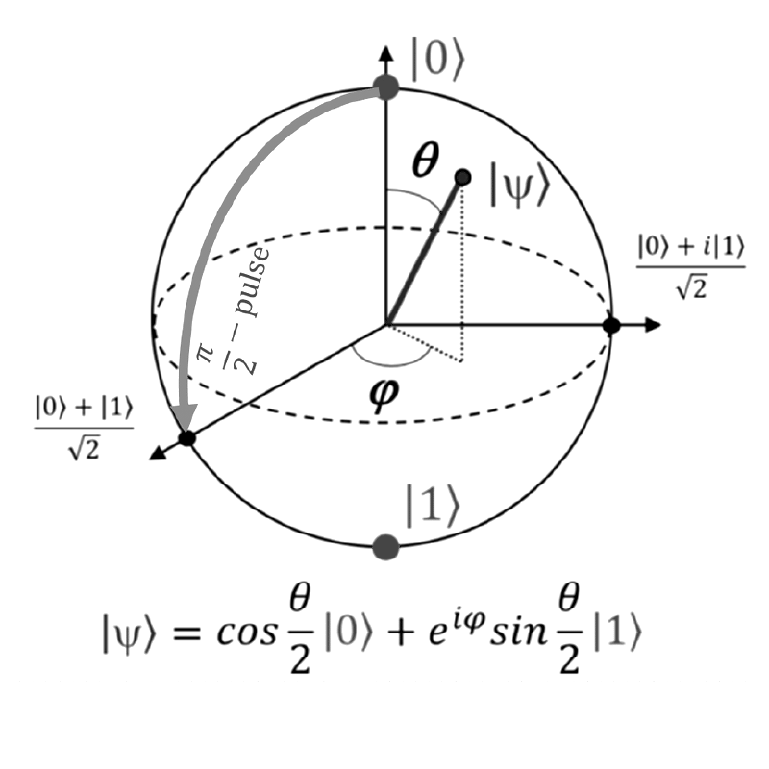
We are faced with ever larger data sets potentially providing new insights. In response, machine learning algorithms are becoming ever more complex themselves, with current deep belief networks having adjustable parameters that number in the millions and more. But this comes as a high price: the curse of dimensionality. Adding new dimensions or columns to our data creates an exponential growth in the number of possible states in a state space. And at some point, we will reach the physical limits of our hardware in terms of computation speed and storage capacity. However, quantum computing effectively overcomes this problem by turning any linear increase in the dimensionality of a state space, into a linear increase in the number of qubits required. What was once considered to be an intractable problem to solve for even a large group of supercomputers working in unison, now becomes reality with only a handful of Qubits. At the core, classical and quantum computing use the same paradigm: both operate on packages of data (bit strings) that can represent any type of information of interests (strings, numbers, images). However, qubit greatly expand the number of possible operations we can simultaneously perform on it. In addition, the unique properties of superposition and entanglement (that they inherit from their physical reality) allow for a new set of superpowers: logical operations not possible within the classical computing paradigm. Combined it reveals the true strength and promise of quantum computing: its ability to represent and evaluate many different states of a system at once. If we can prove our quantum computer can solve a known algorithmic problem faster than our conventional computing methods, we have achieved quantum supremacy. Such Quantum Supremacy was recently demonstrated by the Quantum team at Google. This demonstrates the real-world viability of quantum computing beyond an academic interest.

In classical computing, we use bits to represent our data and code. A classical bit is 0 or 1, so the number of different states we can represent with n bits is 2n. Classical computing involves passing bits through logic gates. Our data (bit strings) is operated on, one at a time, by a set of instructions, performing basic binary operations on them. However, a classical register of n bits can only take on one value at a time. At the time of writing, an average MacBook Pro runs at about 1 teraflop, making it capable of performing one trillion (1012) floating-point operations per second. Even at that incredible speed, to test every possible permutation of a 64-bit code, we would need have to run through 2e19 different combination. At 1 teraflop, that takes 20000000 seconds, or roughly 231 days. Quantum computers, on the other hand, use qubits, which are subatomic particles such as electrons or photons. Qubits have some quirky quantum properties. This means that a connected group of them can provide way more processing power, compared to the same number of binary bits. One of those properties is known as superposition and another is called entanglement Qubits can represent numerous possible combinations of 0 and 1at the same time. This ability to simultaneously be in multiple states is called superposition. To put qubits into superposition, researchers manipulate them using precision lasers or microwave beams. Thanks to this counterintuitive phenomenon, a quantum computer with several qubits can crunch through a vast number of potential outcomes simultaneously. The result of a calculation emerges only once the qubits are measured, which immediately causes their quantum state to collapse to either 0 or 1. We can also generate pairs of qubits that are entangled, which means the two members of a pair exist in a single quantum state. Changing the state of one qubit will instantaneously change the state of the other in a predictable way. This happens even if they are separated by very long distances.

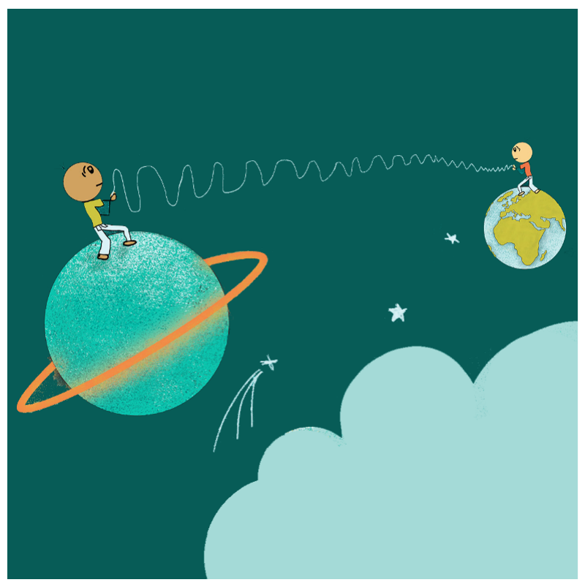

These two concepts are key to the power of quantum computers. Adding extra qubits to a quantum machine produces an exponential increase in its number-crunching ability. Quantum computers harness entangled qubits in a kind of quantum daisy chain to work their magic. The machines’ ability to speed up calculations using specially designed quantum algorithms is why there’s so much buzz about their potential. In quantum computing, we still operate on data by comparing and transforming their states through logical gates. Here, we introduce a formal way of representing and describing qubits and the operations that we can perform on them.The state of a single qubit can be described by a two-dimensional column vector of unit norm, that is, the magnitude squared of its entries must sum to 1. This vector, called the quantum state vector (1), holds all the information needed to describe the one-qubit quantum system. And it represents a qubit state if the vector satisfies (2). Pictured on the right are examples of valid quantum state vectors representing qubits. (3) and (4) are qubits in a classical state, taking on the value 0 or 1. (5) and (6) represent the qubit in a state of superposition of equal probabilities. Now that we know how to represent a qubit, we can gain some intuition for what these states represent by discussing the concept of measurement. A measurement corresponds to the informal idea of looking at a qubit, which immediately collapses the quantum state to one of the two classical states. When a qubit given by the quantum state vector (a) is measured we obtain the outcome 0 with probability and 1 with probabilities (7) and (8).

QP gates
The controlled-NOT gate (also C-NOT or CNOT) is a quantum gate that is an essential component in the construction of a quantum computer. It can be used to entangle and disentangle qubits and their states. Any quantum circuit can be simulated to an arbitrary degree of accuracy using a combination of CNOT gates and single qubit rotations. The CNOT gate operates on a quantum register consisting of 2 qubits. The CNOT gate flips the second qubit (the target qubit) if and only if the first qubit (the control qubit) is [1 0]. To place a qubit into superposition, we use a Hadamard gate (H). This is another essential quantum computing operation as we will see later in a couple of Hello World examples.
If our qubit is currently not in a state of superposition, applying the H gate will do so. In both cases, the qubit goes from its classical definite state (0 or 1) into a superposition state of equal probability. However, depending on the state of the qubit prior to the operation, the resulting superposition states will differ in terms of phase.
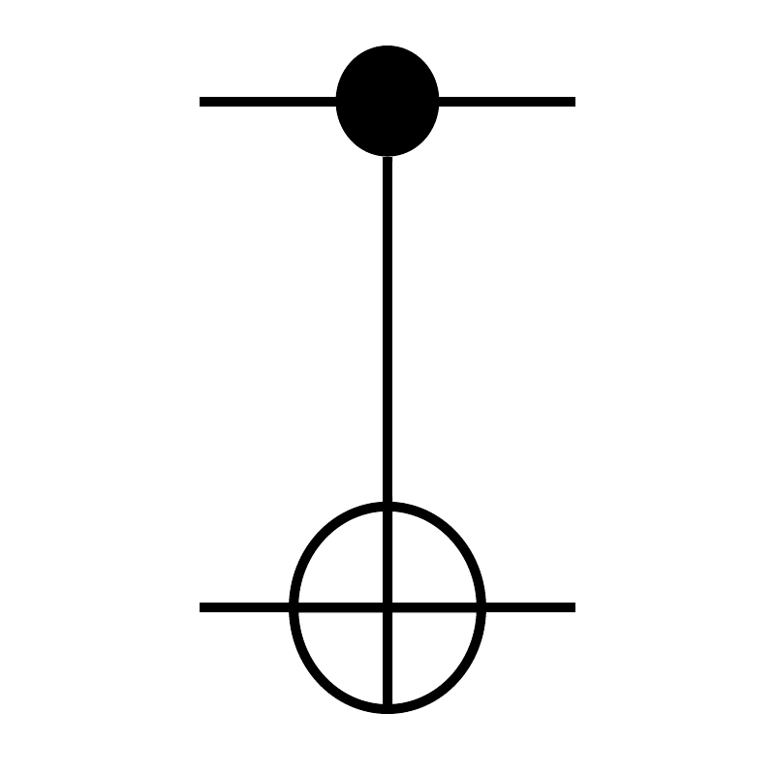
This phase difference allows the H gate to be its own inverse, in the same way a NOT gate is its own inverse in classical computing. If we apply the H gate twice, we end up with the exact same qubit state as we started with. This is essential to quantum computing and the algorithms we implement.

Quantum Computing - Use Cases
The following is a non-exhaustive list of potential use cases. They do share a common underling theme: all of them deal with a level computational complexity that scales poorly in classical computing frameworks.

Use Case: Linear Systems
Key to many machine learning algorithms is the high dimensional algebra that needs to be performed. Most computationally expensive are matrix multiplications, dot products, inverses and convolutions. With quantum computing, these large mathemetical operations can be carried out all at once, on all the elements of our data simultanously, rather than the serial process of our conventional CPU based computers. Similarly, Google’s PageRank algorithm emulates random walks processes, used to compute the strength between links. Quantum computing can speed up the necessary calculating needed to compute PageRank and related graph metrics used by social media services, or graph databases.

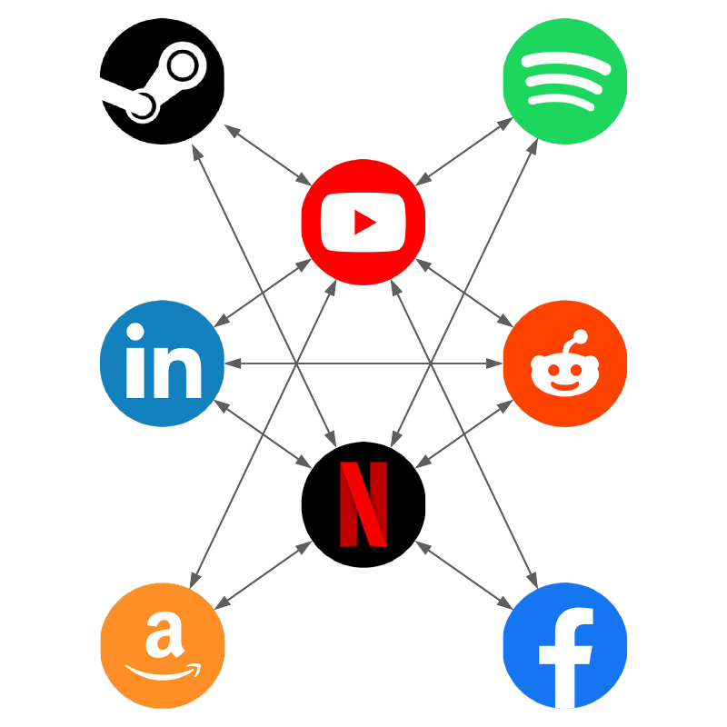

Hidden Markov Models are used to capture the likelihood of transition between states. In natural language processing, they are used to predict the likelihood of a word, given the words already observed in the text, in some order. Because there are so many possible transitions, estimating the probabilities associated with them becomes exponentially harder with more states being added. Each probability is a weighted function of all other probabilities. Quantum computing would allow to quickly resolve this system of dependents, in the same way that it allows us to solve many linear equations in parallel.

The protein folding problem is the question of how a protein's amino acid sequence dictates its three-dimensional atomic structure. Our ability to efficiently design proteins with a specific structure, and therefore biological properties will push forward medical research in terms of drug development. Rather than expensive laboratory experiments, computer simulations can predict protein structure directly from low level features. However, current models predicting these structures are incomplete and therefore lack the required level of accuracy. The exponential growth of potential conformations (folding structures) with chain length makes the problem challenging for classical computers. For example, in one model, a chain of 20 amino acids has 109 potential conformations, and chains with 60 and 100 amino acids have 1028 and 1047 conformations, respectively. Quantum computing has the potential to overcome many of these computational challenges – for example, scoring the great number of possible structures and identifying the most promising one.
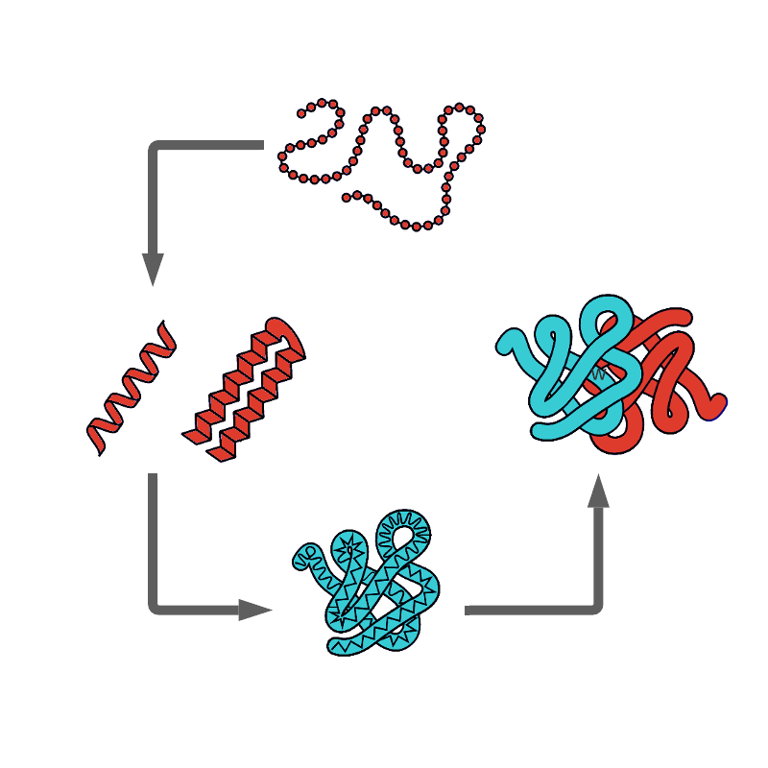

Use Case: Genomes and outcomes
Continuing the same theme once more, finding cause and effect between the complexity of human genome and its additional epigenetic effects to an equally complex space of observable outcomes will require shifting through an extremely large space of possible interactions and directional effects.

Use Case: Encryption and Security
Quantum computing and its ability to explore large state spaces at high speed creates a problem for our current encryption methods. However, it also offers new ways to encrypt and secure sensitive data, at a level far deeper than current technologies can deliver on. We will demo this approach in the Hello World section below.


Spy Hunter Demo
Imagine I ask someone to deliver a handwritten note to another person, with the specific instruction that they cannot read it, or have anyone else by the recipient to read it.



In the classical world without the quantum phenomena of superposition and entanglement, there is no way of ever knowing whether this has happened anyway by examining the note on arrival. You cannot tell from looking at the note whether someone else has read it before you. However, in the quantum world, reading the note as akin to an observation, a measurement.
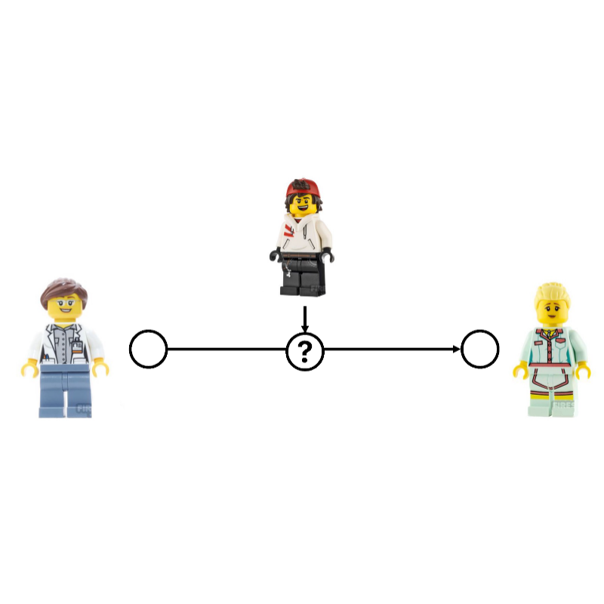
And as such, it has a potential lasting effect on the note itself, because such a measurement will collapse any part of the note that was in superposition. Currently, we cannot put entire pieces of paper into a state of superposition (although it has already been done with molecules. We can though, use qubits, instead of pieces of paper, to send our information. And these, we can put into a state of superposition. The following example highlights how the phenomenon of superposition used in quantum computing can provide a level of security unheard of before.

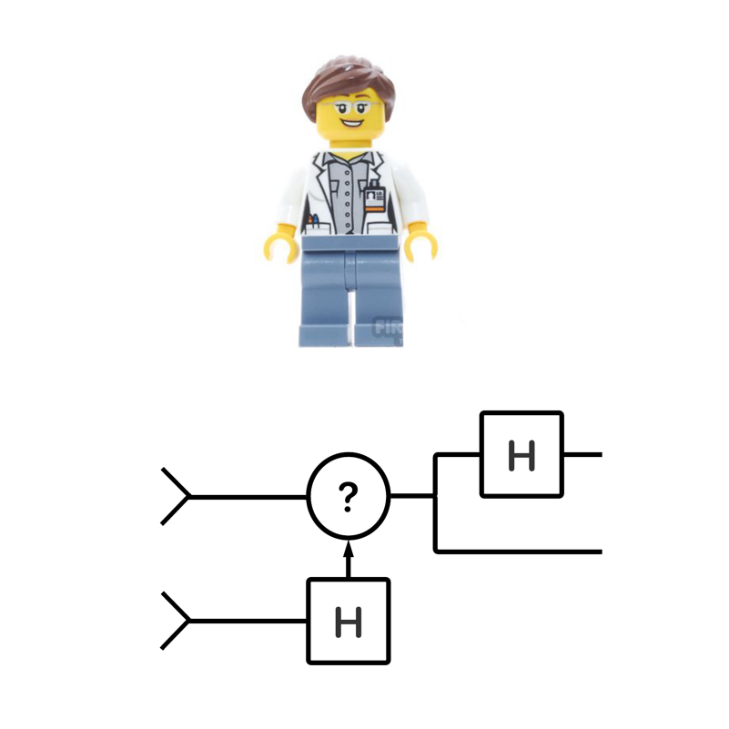

More specifically, it allows use to determine whether a piece of sensitive data has been intercepted and copied during transfer. Imagine that Heidi and Ada want to exchange data but want to make sure the data isn’t seen by anyone during transmission, especially not Thomas who has nefarious plans with the data and a means to tap the channel that Ada and Heidi are communicating on. The following is a series of steps that will tell Ada and Heidi whether their information has been intercepted.
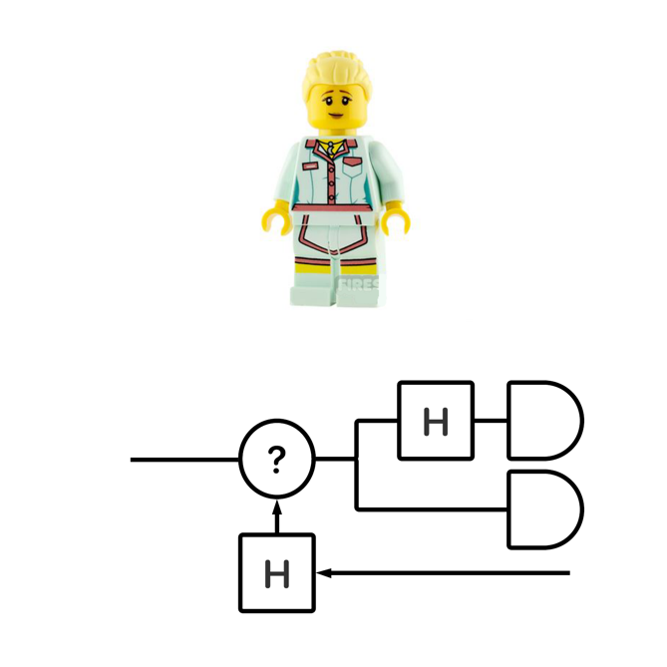
Ada is the one to send a bit of information. To do so, she uses two qubits. The first she uses to flip a coin uses the outcome to decide whether to put the second one into a superposition or not. She logs the decision and sends the qubit, which can be |0> or |1> if she didn't apply the Hadamard or |+> or |-> if she did use the Hadamard. Heidi will have to read the bit of information set gets from Ada. To do so, she also uses two qubits: one of her own, and the one she received through the channel. She uses her own qubit s to flip a coin to decide whether to pass the received qubit through a Hadamard gate, exactly like Ada did. And after that, whether it is passed through the H gate or not, Heidi reads the received qubit and logs the data and her decision to apply the Hadamard gate or not.
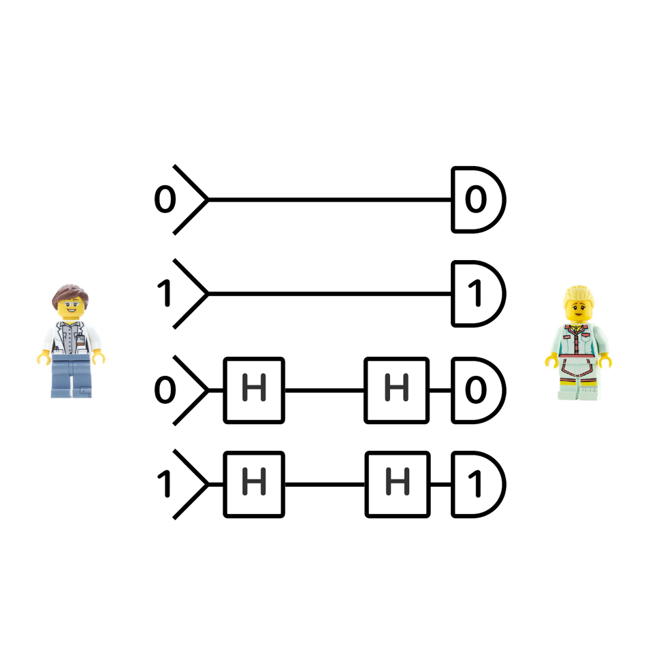
Let's look at the all the possible scenarios that can play out in this process. From this, we will be able to conclude that Heidi can decode Ada's information, even without knowing, at the time (this is important) what Ada did to the qubit prior to sending it. Scenario 1. In the first scenario, neither Ada or Heidi decide to put the qubit into a state of superposition. This defaults to a classical computing situation: Heidi simply reads exactly what Ada has send. Scenario 2. Alternatively, both Ada and Heidi decide to put the qubit into a state of superposition. Remember that stringing two Hadamard gates to together has the second H gate undo the operation of the first.
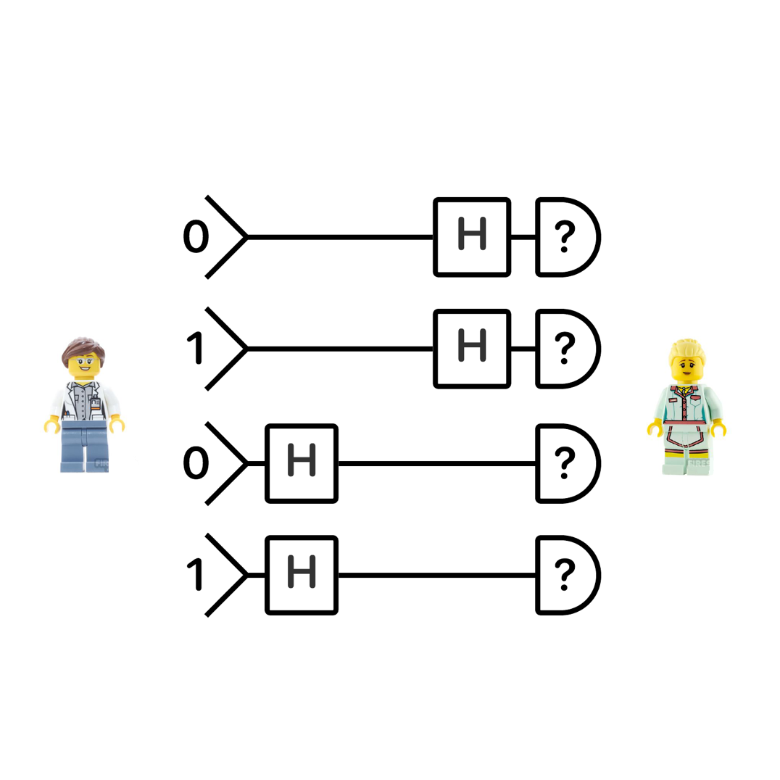
Therefore, if both apply the H gate, the qubit state that Heidi observes is the state Ada send. Scenario 3. Heidi put the qubit in superposition, but Ada does not pass it through a H gate again. That means that when she reads the qubit, she collapses it state: it will be 0 in 50% of the cases, 1 in the other 50% of the cases. But more importantly, the state of the qubit Heidi observes is decorrelated completely from what Ada set it to.
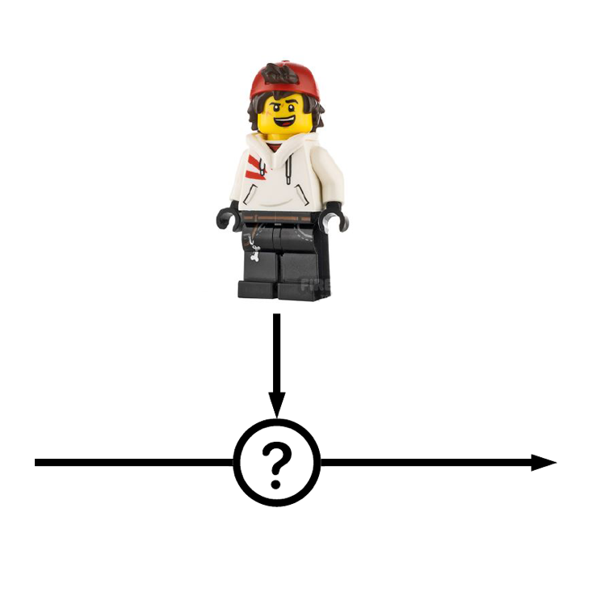
Scenario 4. Here, Ada does not apply the H gate before sending, but Heidi applies when receiving it before reading. Like scenario 3, this sequence of events breaks the correspondence to what Ada set the qubit to and what Heidi reads out. The qubit comes to Heidi in non-superposition state. However, by putting it into superposition before reading, Heidi basically recreates the random number outlines at beginning of this section. If Ada and Heidi compare notes about what they did to the qubit prior and after sending/receiving it, they should also agree on the bit state if they both applied or both did not apply the H gate operation. When this correspondence breaks down, it means something is interfering during transfer of the information. Imagine that Thomas wants to steal the bit of information. He decides to secretly reads the bit in transfer. He does not know whether Ada but the qubit in superposition, that information is not communicated through the channel until after the entire message has been send. Therefore, in reading it, he potentially collapses the superposition, leaving him with a random qubit state that has nothing to do with the information that Ada is sending to Heidi. Even more problematic, he cannot undo this operation, pretending the qubit was never read. Again, reading it alters the qubits state in some instances. He can therefor only send a new qubit, but has no idea what he should set it to. No matter what clever trick he uses to send a new qubit to Ada, pretending it was never read to begin with, Ada and Heidi will stop seeing an agreement between qubit states when they both apply or not apply the H gate operation.

Resources

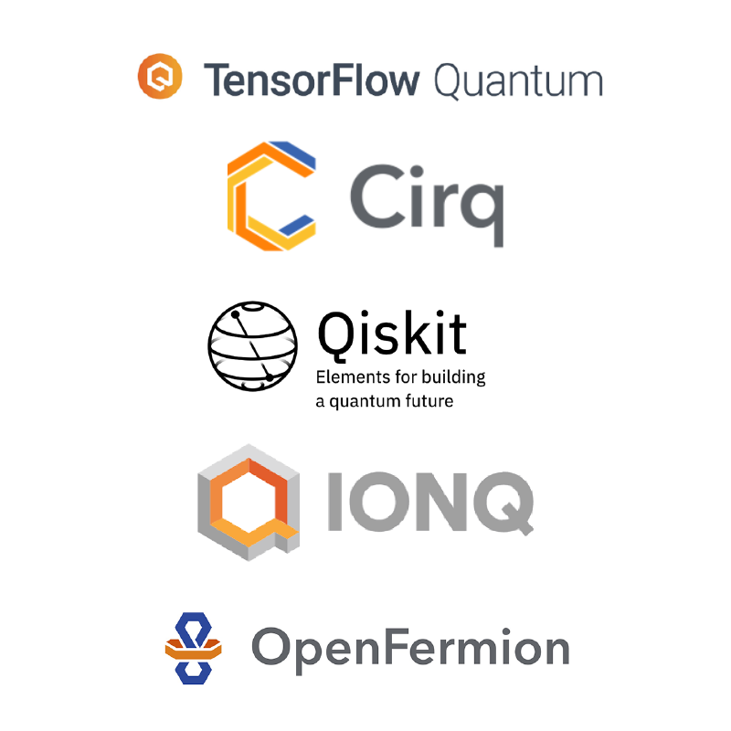

Resources

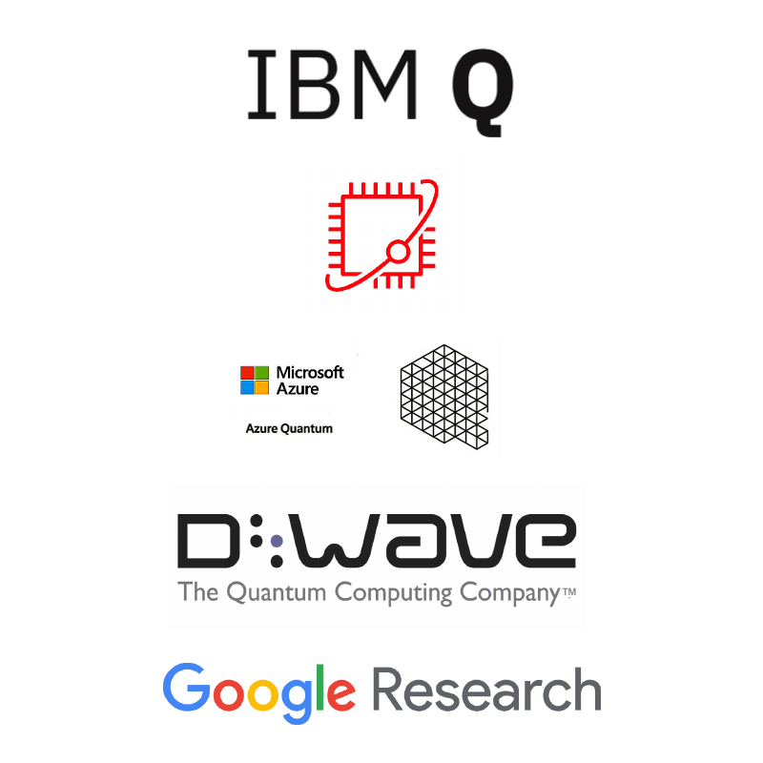

Surag Nair

## 28.3 - GPT-3

## 28.4 - Reinforcement Learning
Reinforcement Learning(RL) is one of the hottest research topics in the field of modern Artificial Intelligence and its popularity is only growing. Let’s look at 5 useful things one needs to know to get started with RL.
1. What is Reinforcement Learning? How does it compare with other ML techniques?
Reinforcement Learning(RL) is a type of machine learning technique that enables an agent to learn in an interactive environment by trial and error using feedback from its own actions and experiences.

Though both supervised and reinforcement learning use mapping between input and output, unlike supervised learning where the feedback provided to the agent is correct set of actions for performing a task, reinforcement learning uses rewards and punishments as signals for positive and negative behavior.
As compared to unsupervised learning, reinforcement learning is different in terms of goals. While the goal in unsupervised learning is to find similarities and differences between data points, in the case of reinforcement learning the goal is to find a suitable action model that would maximize the total cumulative reward of the agent. The figure below illustrates the action-reward feedback loop of a generic RL model.

2. How to formulate a basic Reinforcement Learning problem?
Some key terms that describe the basic elements of an RL problem are:
Environment — Physical world in which the agent operates
State — Current situation of the agent
Reward — Feedback from the environment
Policy — Method to map agent’s state to actions
Value — Future reward that an agent would receive by taking an action in a particular state
An RL problem can be best explained through games. Let’s take the game of PacMan where the goal of the agent(PacMan) is to eat the food in the grid while avoiding the ghosts on its way. In this case, the grid world is the interactive environment for the agent where it acts. Agent receives a reward for eating food and punishment if it gets killed by the ghost (loses the game). The states are the location of the agent in the grid world and the total cumulative reward is the agent winning the game.

In order to build an optimal policy, the agent faces the dilemma of exploring new states while maximizing its overall reward at the same time. This is called Exploration vs Exploitation trade-off. To balance both, the best overall strategy may involve short term sacrifices. Therefore, the agent should collect enough information to make the best overall decision in the future.
Markov Decision Processes(MDPs) are mathematical frameworks to describe an environment in RL and almost all RL problems can be formulated using MDPs. An MDP consists of a set of finite environment states S, a set of possible actions A(s) in each state, a real valued reward function R(s) and a transition model P(s’, s | a). However, real world environments are more likely to lack any prior knowledge of environment dynamics. Model-free RL methods come handy in such cases.
Q-learning is a commonly used model-free approach which can be used for building a self-playing PacMan agent. It revolves around the notion of updating Q values which denotes value of performing action a in state s. The following value update rule is the core of the Q-learning algorithm.

Here’s a video demonstration of a PacMan Agent that uses Deep Reinforcement Learning.

3. What are some of the most used Reinforcement Learning algorithms?
Q-learning and SARSA (State-Action-Reward-State-Action) are two commonly used model-free RL algorithms. They differ in terms of their exploration strategies while their exploitation strategies are similar. While Q-learning is an off-policy method in which the agent learns the value based on action a* derived from the another policy, SARSA is an on-policy method where it learns the value based on its current action a derived from its current policy. These two methods are simple to implement but lack generality as they do not have the ability to estimates values for unseen states.
This can be overcome by more advanced algorithms such as Deep Q-Networks(DQNs) which use Neural Networks to estimate Q-values. But DQNs can only handle discrete, low-dimensional action spaces.
Deep Deterministic Policy Gradient(DDPG) is a model-free, off-policy, actor-critic algorithm that tackles this problem by learning policies in high dimensional, continuous action spaces. The figure below is a representation of actor-critic architecture.

4. What are the practical applications of Reinforcement Learning?
Since, RL requires a lot of data, therefore it is most applicable in domains where simulated data is readily available like gameplay, robotics.
RL is quite widely used in building AI for playing computer games. AlphaGo Zero is the first computer program to defeat a world champion in the ancient Chinese game of Go. Others include ATARI games, Backgammon ,etc
In robotics and industrial automation, RL is used to enable the robot to create an efficient adaptive control system for itself which learns from its own experience and behavior. DeepMind’s work on Deep Reinforcement Learning for Robotic Manipulation with Asynchronous Policy updates is a good example of the same. Watch this interesting demonstration video.

Other applications of RL include abstractive text summarization engines, dialog agents(text, speech) which can learn from user interactions and improve with time, learning optimal treatment policies in healthcare and RL based agents for online stock trading.
5. How can I get started with Reinforcement Learning?
For understanding the basic concepts of RL, one can refer to the following resources.
Reinforcement Learning-An Introduction, a book by the father of Reinforcement Learning- Richard Sutton and his doctoral advisor Andrew Barto. An online draft of the book is available here.
Teaching material from David Silver including video lectures is a great introductory course on RL.
Here’s another technical tutorial on RL by Pieter Abbeel and John Schulman (Open AI/ Berkeley AI Research Lab).
For getting started with building and testing RL agents, the following resources can be helpful.
This blog on how to train a Neural Network ATARI Pong agent with Policy Gradients from raw pixels by Andrej Karpathy will help you get your first Deep Reinforcement Learning agent up and running in just 130 lines of Python code.
DeepMind Lab is an open source 3D game-like platform created for agent-based AI research with rich simulated environments.
Project Malmo is another AI experimentation platform for supporting fundamental research in AI.
OpenAI gym is a toolkit for building and comparing reinforcement learning algorithms.

## 28.5 - Swarm Intelligence
Swarm intelligence (SI) is the collective behavior of decentralized, self-organized systems, natural or artificial. The concept is employed in work on artificial intelligence. The expression was introduced by Gerardo Beni and Jing Wang in 1989, in the context of cellular robotic systems.[1]

SI systems consist typically of a population of simple agents or boids interacting locally with one another and with their environment.[2] The inspiration often comes from nature, especially biological systems. The agents follow very simple rules, and although there is no centralized control structure dictating how individual agents should behave, local, and to a certain degree random, interactions between such agents lead to the emergence of "intelligent" global behavior, unknown to the individual agents.[3] Examples of swarm intelligence in natural systems include ant colonies, bee colonies, bird flocking, hawks hunting, animal herding, bacterial growth, fish schooling and microbial intelligence.

The application of swarm principles to robots is called swarm robotics while swarm intelligence refers to the more general set of algorithms. Swarm prediction has been used in the context of forecasting problems. Similar approaches to those proposed for swarm robotics are considered for genetically modified organisms in synthetic collective intelligence.[4]

### 28.6 - Complexity Theory and Agent Based Modeling

## 28.7 - Quantum Machine Learning
Quantum computing is the use of quantum phenomena of superposition and entanglement to perform computations.
Exploiting these phenomena gives quantum computers the ability to represent, iterate over as well as search through extremely large state spaces with relatively little computing resources, such as physical memory and circuitry. As such, the applications of quantum computing focus on improving algorithms that show exponential growth in complexity in classic computing environments. Drawbacks are the need for extremely specialized hardware, substantial noise in the measurements and a significant paradigm shift in algorithmic and data structure design.

{{{{{{}}}}}}

## 28.8 - References
https://www.nature.com/articles/s41467-021-22539-9.pdf

